EXPERIMENT Q10:
Quantum Interference
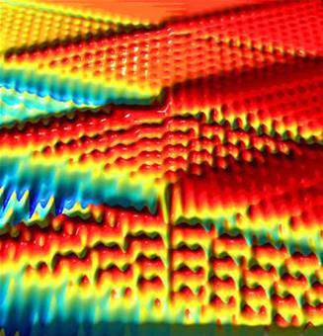

Introductory Material

One of the more difficult conceptual paradigms in quantum mechanics is the so-called “wave-particle duality” of many entities. Fundamentally, this is simply a complicated way of stating that electrons, neutrons, protons, and other quantities we normally consider particles display certain properties more typically associated with waves. In discussing the photoelectric effect, we saw that the photon also exhibits this dual nature. Since Young’s double-slit experiment in the early 19th century, the wave nature of light has been well established. However, as noted in Lab Q1, the wave model of light did not satisfactorily explain all of the observed properties of photoemission of electrons. To resolve this, Einstein proposed that light waves carried energy in discrete “quanta” that we call photons.
Einstein’s Nobel Prize for this explanation does not undermine the wave-like interference patterns displayed by light (or electrons for that matter), but it does emphasize that particle properties and wave properties are not mutually exclusive. Grasping the different properties of matter (and especially the distinctions between those deemed similar to waves as opposed to particles) is a key step towards understanding and using quantum mechanics.
It is possible to perform a single experiment which demonstrates both of these types of properties for a specific type of matter. In a nice twist of scientific irony, we shall use a variant of Young’s double slit experiment to demonstrate both particle and wave behavior by photons.
At this point, Young’s double slit experiment should need no further introduction to most students. It is important to note that the interference pattern is a distinctly wave-related phenomenon, and that it is independent of the intensity of the incident light. The particle nature of light will be demonstrated by measuring individual events where the photons arrive at specific points and are recorded by a photomultiplier tube. The pattern in which large numbers of these arrive will reproduce the familiar double slit interference pattern.
As noted before, this pattern is independent of the intensity of light. Exploiting this, the interference pattern will continue to be present even when the intensity of light is sufficiently low that only one photon is present in the apparatus at a time.
Wait a minute, how can there be an interference pattern if there’s nothing to interfere with? How can a single photon “know” about the presence of both slits and form an interference pattern? These sorts of questions have puzzled many introductory physics students (as well as the general public) for years. However, without going into questions of this sort, we can clearly demonstrate that this counterintuitive phenomenon of a single particle yielding an interference pattern does indeed occur.
The University of Iowa Physics Department currently only has a single apparatus designed for this experiment. This will require a larger scale of collaboration than is typical for this course, or indeed any of the other labs in the curriculum. Thus a certain division of labor will be written into the laboratory instructions, with the implication that student participation will impact the grading scheme for the lab. Consider this written notice.
This lab will produce the two-slit interference pattern with a red-wavelength laser, allowing for certain baseline measurements of the apparatus to be made. It will also allow for quantitative measurement of the two-slit interference pattern, taking detailed measurements of the intensity of light arriving at various points in the pattern. Further, reducing the intensity will permit the quantitative measurements to be reproduced when only one photon is present in the apparatus at a given time.

Pre-Laboratory Questions
- For the first part of this lab, the expected power delivered to the photodiode is estimated at .1 microwatts. Assuming the red laser has a 670nm wavelength, what is the rate at which photons are arriving at the detector?
- Assuming the apparatus is one meter long, how many photons per second can be produced and still have (on average) exactly one photon traveling from the source to detector at any given time? If we use green light of wavelength roughly 550 nm, what power of laser does this correspond to?

Equipment List

TeachSpin two-slit interference apparatus, including photodiode and photomultiplier tube
Frequency counter
Oscilloscope
Computer software for plotting data

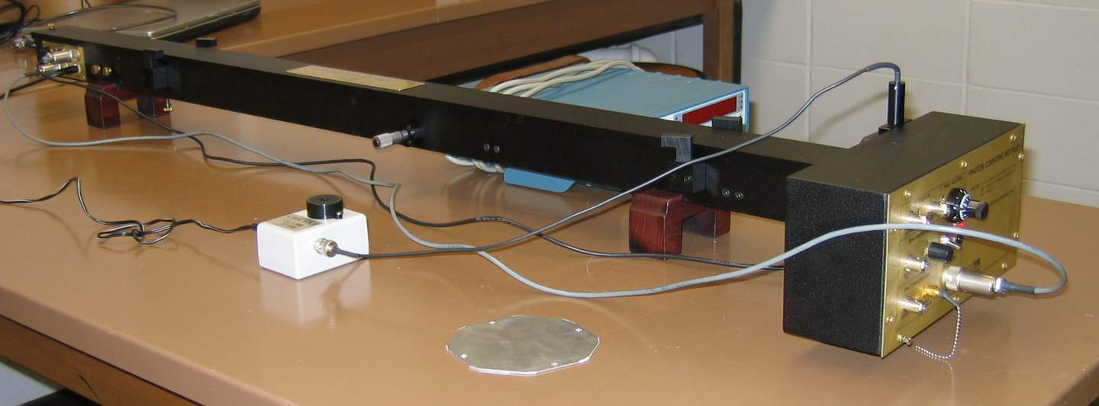
Figure 10-1: Apparatus shown with lid in place.

Experimental Procedure

Part I: Alignment and Preparation
Initial work will be done with the red laser inside the apparatus. This will allow for easier alignment and initial measurements.

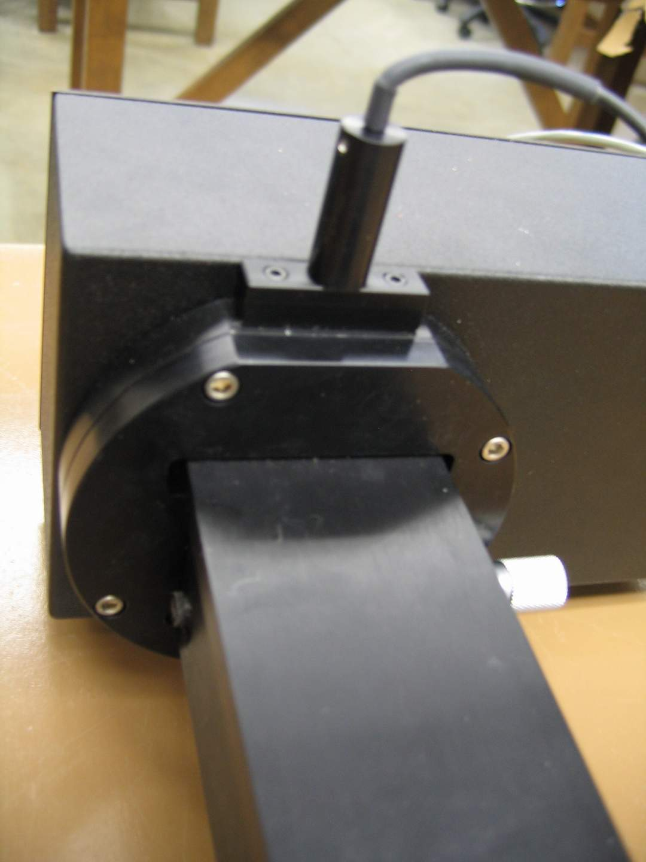
Figure 10-2: Light-blocker shown in “closed” position.
Make sure that the shutter at the end of the apparatus nearest the detector is in the “down” position, with the high voltage for the photomultiplier tube set to “off” and 0 Volts (See Figure 5). When the shutter is in the “down” position, only the photodiode will receive light. When the shutter is “up”, light will reach the photomultiplier tube. As the photomultiplier tube is very sensitive, it should only receive light when the lid of the apparatus is closed.

After removing the lid, one student will need to ensure that the green-filtered bulb is removed from the path of the laser light. To do this, adjust the brass screw underneath the light source so that the light source can be lowered out of the path of the laser light. (Note: The brass screw is not visible in the picture here.)
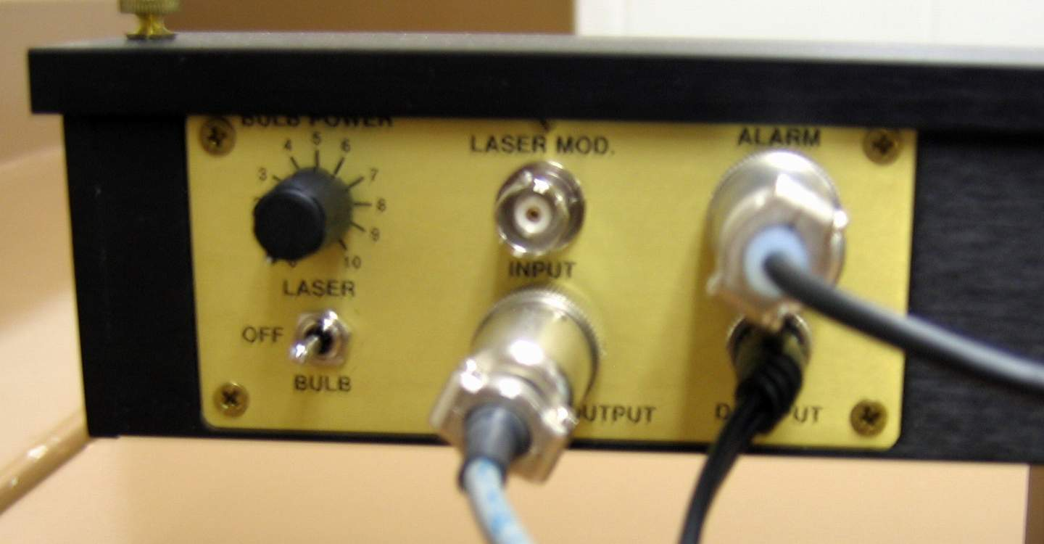
Figure 10-3: Light controls

With the light source control switch set to “laser”, using a piece of white paper (index cards also work) to track the beam, make sure that the laser is aligned so that the beam passes through the initial aperture and lands squarely on the double slit located at the first micrometer. The brass knobs on the side of the apparatus control the horizontal position, while the nylon knob behind the laser controls the vertical position.

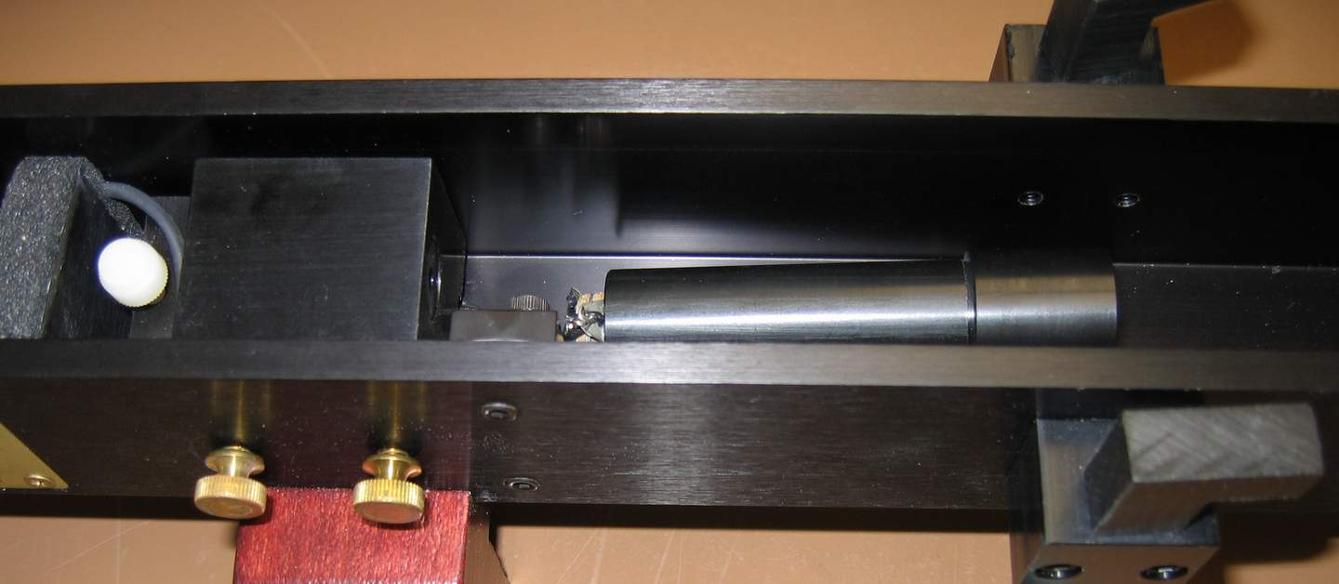
This first micrometer (See Fig. 10-6) controls the location of a wider slit which can be used to block light passing through either (or both or none) of the two slits, as desired. One student will need to track the various positions where this large slit can be positioned to achieve each of these outcomes. Thus, for later uses, you will obtain regions whereby light from both slits passes through unimpeded or just through a specific slit. These must be recorded for later use with the lid closed above the apparatus. If the number of students permits, different students should take and record the data. The chalkboard is convenient for this purpose. (Note: manufacturer specifies slit center-to-center separation as .353 mm and slit width of .085 mm each.)
Figure 10-4: Laser (in block on left) and Light bulb

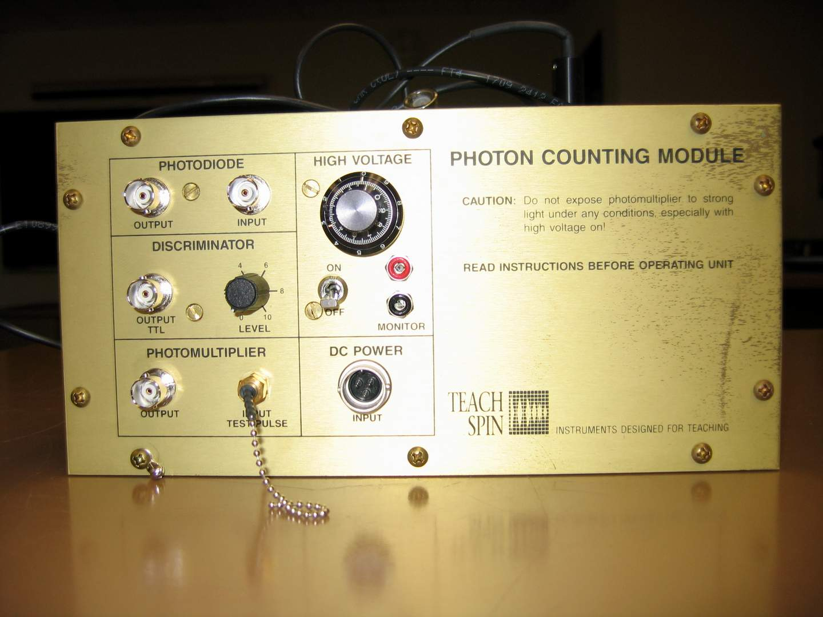
Observe the changes between single-slit diffraction and double-slit interference at the detector end of the apparatus. Having confirmed the appearance of these patterns, quantitative measurements can begin.
Figure 10-5: Counting Module

Part II: Double slit interference
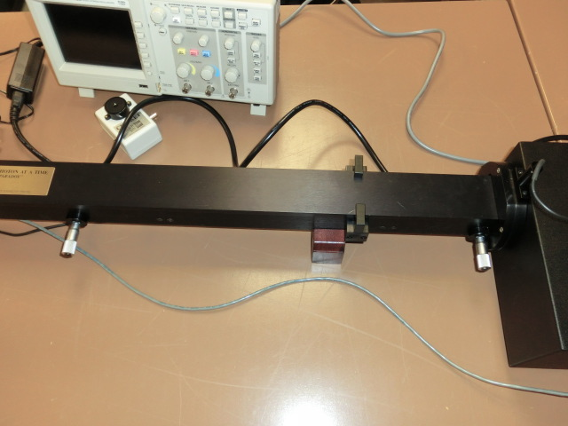
Connect a digital multimeter to the output BNC connector for the photodiode. The voltage output reading will correspond to the incident light on the photodiode. Replace the lid on the top of the apparatus to keep the ambient light from swamping your signal.
Figure 10-6. The unit has 2 micrometers.
1st Micrometer: Slit Blocker
2nd Micrometer: Detector Position
Briefly turn off the laser to obtain the zero offset of the photodiode. Turning off the overhead lights should confirm whether the apparatus is “light-tight.”

Locate the central maximum of the two slit interference pattern using the second micrometer (See Fig. 10-6). Record the output voltage. Then move the slit blocker to permit light to pass through only one slit. Compare your reading (corrected by the zero-offset, of course) to the intensity with two slits.

Plot intensity versus position for the laser for the two slit interference pattern as well as each of the two individual single slit diffraction patterns. It is recommended to have one student moving the detector micrometer, a second reporting output voltages, and a third recording these values for plotting. You will need sufficient data points to clearly show the diffraction pattern.

Part III: Single Photon Interference
Set the slit blocker to permit light from both slits to reach the detector. Set the detector slit to the central maximum. Toggle the laser off, open the apparatus, and raise the light bulb into position to use the bulb as a source for the single-photon mode. Dial the bulb power to zero, then switch the light control to turn the bulb on, then slowly increase the bulb power until it produces sufficient light to be visible. Darken the room and check that the bulb is aligned so that a double-slit diffraction pattern reaches the detector at the far end of the apparatus.

Dial the bulb power back to zero. Toggle the bulb off. Replace the lid. Use the photodiode to make sure that no ambient light is entering the detector. Set the shutter to the up position, so that light may reach the photomultiplier tube (PMT).

Connect the oscilloscope to the Photomultiplier output BNC connection, use a 50 Ohm terminator at the oscilloscope to avoid unwanted reflections (remember S1?). Set the high voltage dial to zero and turn on the high voltage to the PMT. Set the oscilloscope to 50 mV/div, 250 ns/div, and to trigger on positive pulses of about 20 mV or more. With the bulb power still dialed down to zero, toggle the bulb switch back on (you must do this or there will be no voltage to the PMT). Slowly dial up the bias voltage until you start seeing positive pulses on the oscilloscope (maybe 1-10 per second). There will be some (mV level) noise of roughly 200kHz. A high rate of pulses from the PMT (>10kHz) is problematic, and you will need to restart this step, rechecking that there is no light leakage. This is the “dark rate” of the PMT, the number of counts in the absence of light.

Connect the TTL output to the second channel on your oscilloscope. Adjust the discriminator setting on the detector so that you get exactly one pulse for each analog pulse that reaches roughly +50 mV. You may need to adjust your PMT bias if your pulses are too low.

Now connect the TTL output to your frequency counter. Record the “dark rate” of background counts with the bulb off. Turn the bulb back on, and dial it up until you reach roughly 1000 counts/s, then use your slit blocker to block both slits. This should have a slightly higher count rate than the dark rate, but will still be considered background with the bulb lit.

Record the number of counts/s for various different detector locations at this low count rate to confirm that double slit interference is taking place, even at this much reduced intensity.

Instead of a steady output, the number of photons arriving will fluctuate somewhat. Thus, average the number of counts per second over 10-12 seconds for each location of the detector. At your TA’s discretion, you can make each of these measurements independently and calculate the standard deviation of each point.

(Based on time, more can be added, e.g. varying intensity to check the root-N value of sigma, as well as changes based on PMT voltage…)

Part IV: Clean Up

- Turn all dials to zero and toggle all switches to the “off” position.
- Tidy the lab bench and exit any running software.

Analysis Questions

- You probably saw that with light incident from only one slit, the intensity at the central maximum was less than half the value when two slits were present. Provide an explanation.

